Data Thief V1.0 (Beta)

Data Thief uses techniques discribed in paper Manipulating MS SQL Server using SQL injection, to retrieve information from databases of web applications vulnerables to SQL injection which use SQL Server as a backend database server and doesn’t filter well outbound connections.
Data Thief will extract the data from the databases of the vulnerable web application and also it will display the data after sending the data to a SQL Server that you control.
Before using this tool you must find in the web application one entry point to exploit SQL injection, ie: you find http://somesite.com/test.asp?search=someth’ing is vulnerable, then try to find an entry point in the query string of the vulnerable url to insert SQL like http://somesite.com/test.asp?search=something’; select 1-- , after that you can start using Data Thief.
After finding an entry point to exploit SQL injection in the web application, the only thing you have to do is to replace in the SQL injection entry point in the url query string or in the Post Data if the data is submited by HTTP POST method with <***>.
ie: http://somesite.com/test.asp?search=something’; <***>

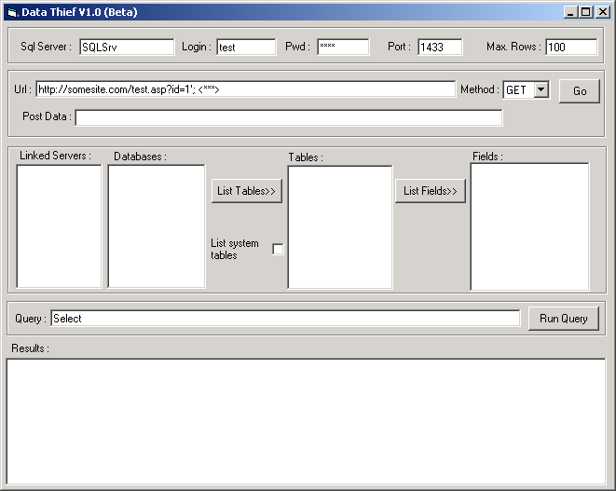
2
1

1)
SQL Server : server name of a SQL Server that you control.
Login: login of a SQL Server that you control.
Pwd: login password of a SQL Server that you control.
Port: listening port of a SQL Server that you control.
Max. Rows: maximum number of rows returned in queries from the victim.

2)
Url: complete url vulnerable to SQL injection.
Method: HTTP method used to submit the data.
Post Data: data to be send when selected POST method.
Go: submit the data and retrieve initial SQL Server information (linked servers, databases, version, user, etc.).

After clicking the Go button the main window will display :
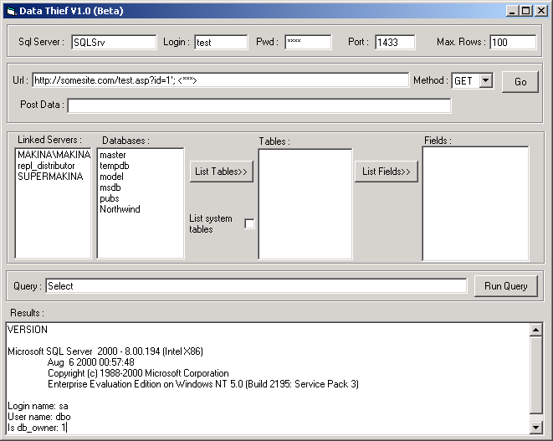
1
2

1)
Linked Servers: displays the linked servers in the victim SQL Server.
Databases: displays the databases in the victim SQL Server.
2)
Results: displays version, login name, user name, etc. of the victim SQL Server.

Once databases are displayed you can chose a database and click List Tables button to display the database tables, you can set to the option List system tables to display or not sytem tables.
After displaying the tables you can chose a table and click List Fields button to display the table fields.
Then you can select the fields to build a query that will be submited when clicking Run Query button, the query will return as much rows you set in the Max. Rows option.

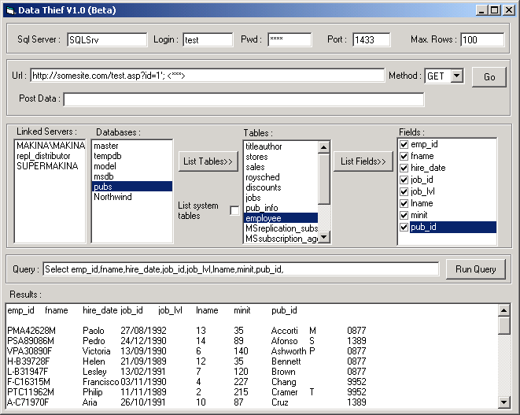
1
2
3

1)
Tables: displays the tables in the selected database after clicking List Tables button.
Fields: displays the fields in the selected table after clicking List Fields buton. The fields names must be selected to build a query.

2)
Query: displays the query build with the selected fields.
Run Query: submits the query.

3)
Results: displays the result of the query after clicking Run Query button. You can cut and paste the results to import them in MS Access, SQL Server, etc.

Data Thief also displays in a window the HTML source code of every response of the vulnerable Web application after submitions. You can look at the HTML source code for error messages if Data Thief doesn’t work.
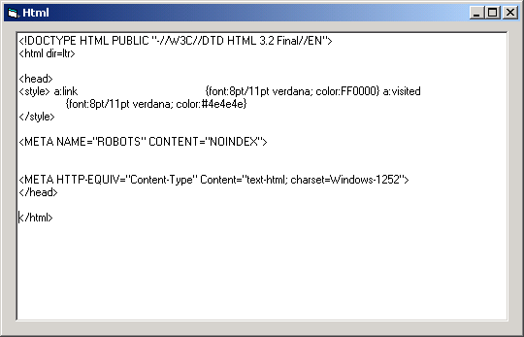

Tips:

-Look in the HTML window for web application error messages when Data Thief doesn’t work, ie: if firewall is blocking outbound connections you will get : [DBNETLIB][ConnectionOpen (Connect()).]SQL Server does not exist or access denied. error message or a similar one.
-Change SQL Server port number to common outbound open ports at firewalls: 80, 53, 25, etc. if you think 1433 could be blocked.
-Decrease Max. Rows value if you or the victim server have an slow connection.
-Edit Data Thief source code to fit your needs (or let me know so i can add them)

TODO:

-Encode urls, post data to avoid detection.
-Display more information.
-Add to execute exploits to elevate privileges in the victim SQL Server depending on version.
-Execute OS commands on the victim server and displays results.
-Option to save query results.
-Many things.

Sugestions, comments, etc. sqlsec@yahoo.com

Cesar.

